

JP – MINI PROJECT

TOPIC – PASSWORD GENERATOR USING JAVA

TEAM MEMBERS

Pragati umate 1032202226

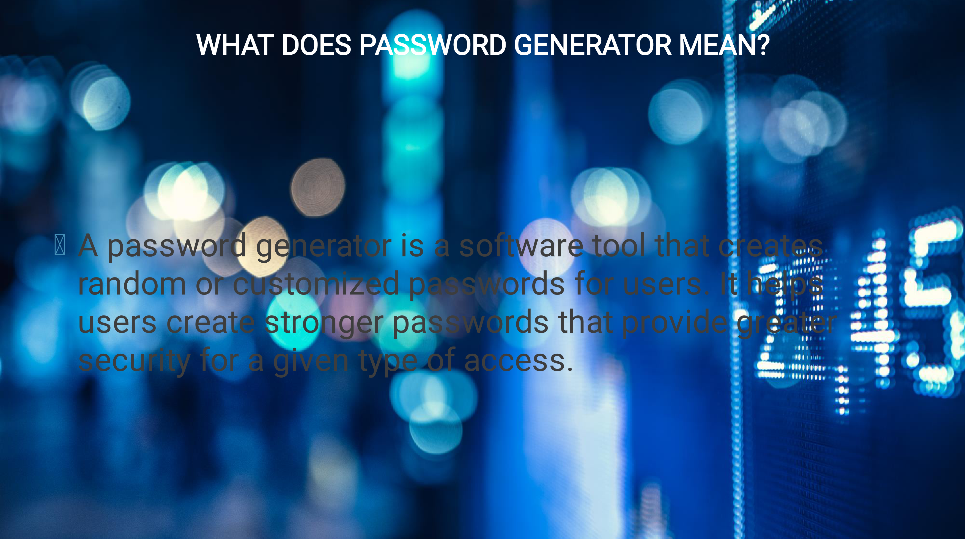

OUR SOLUTION CAN BE USED IN VARIOUS FIELDS :



Networks and

applications



Pseudo Random

Password Protection



Satisfies Current

Standards



Functionalities:



Generating a Password

:

1-



The user must answer by Yes or No the questions to know if he desires to use Uppercase/Lowercase

letters, Numbers or Symbols



The user then enters the desired length of the password



A password alphabet is generated according to the Yes/No answers it is a String that contains the choices

of the user



Depending on the length random characters from the password alphabet are selected and put back to back

to form a totally random string according to the user's needs



The randomly generated password is then displayed on the console

Password-Generator



:

2-

Checking a Password's Strength



The Strength check is based on the following criteria:



The password uses Uppercase Letters



The password uses Lowercase Letters



The password uses Numbers



The password uses Symbols



The length of the password is 8 or more (8 is often the minimum required length for a decent

password)

Password-Generato

r

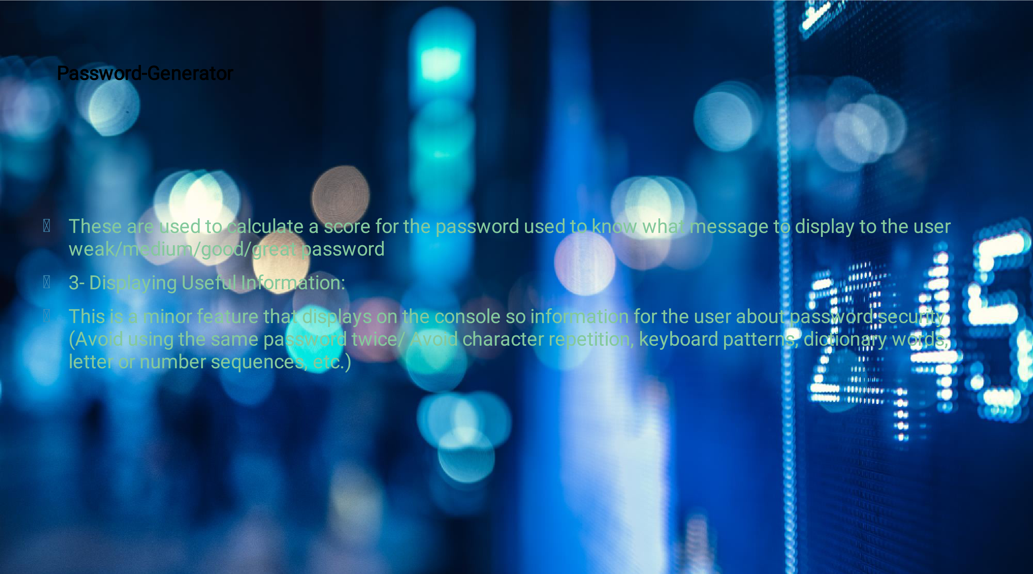



OUTPUTS

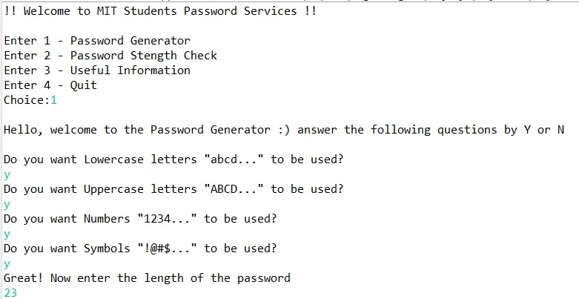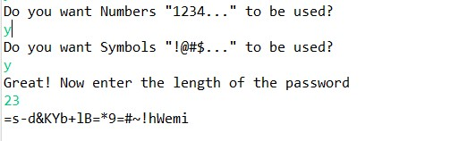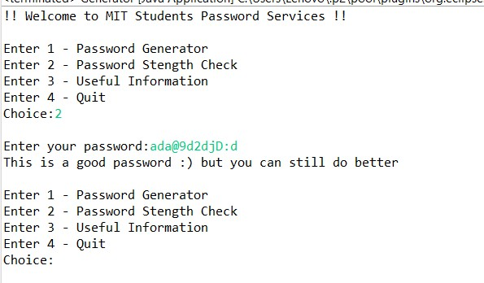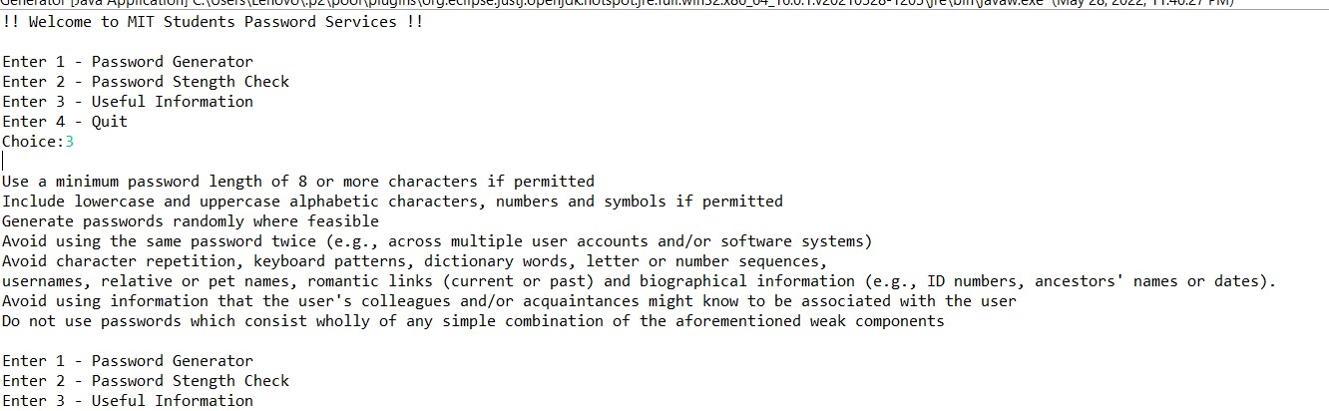

THANK YOU

PANEL - H